**MIDDLETON CHENEY FOOTBALL CLUB**

**ANNUAL GENERAL MEETING**

**1968**

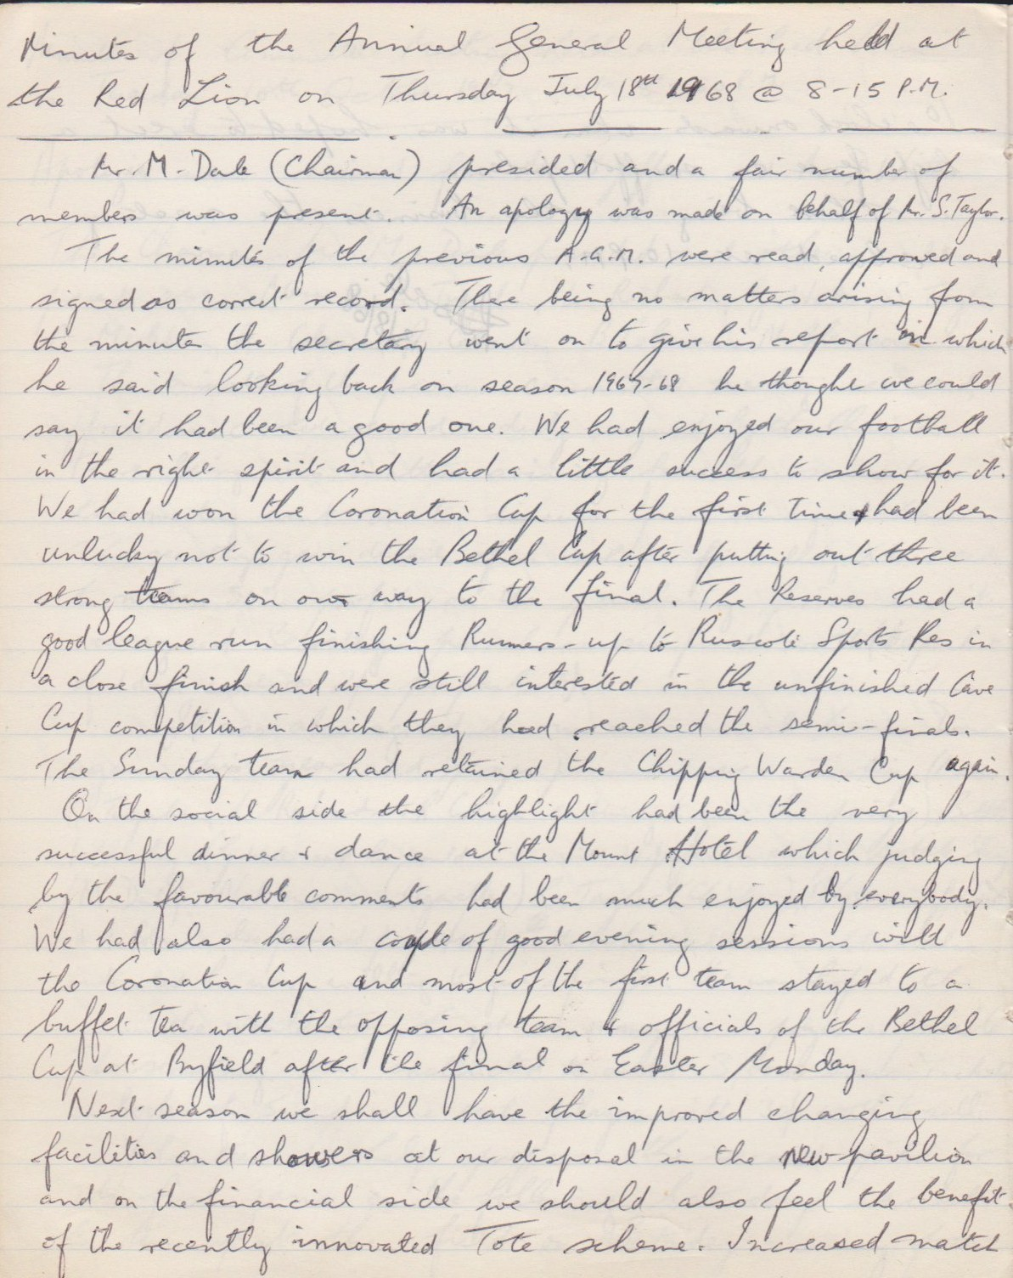

**Continued**

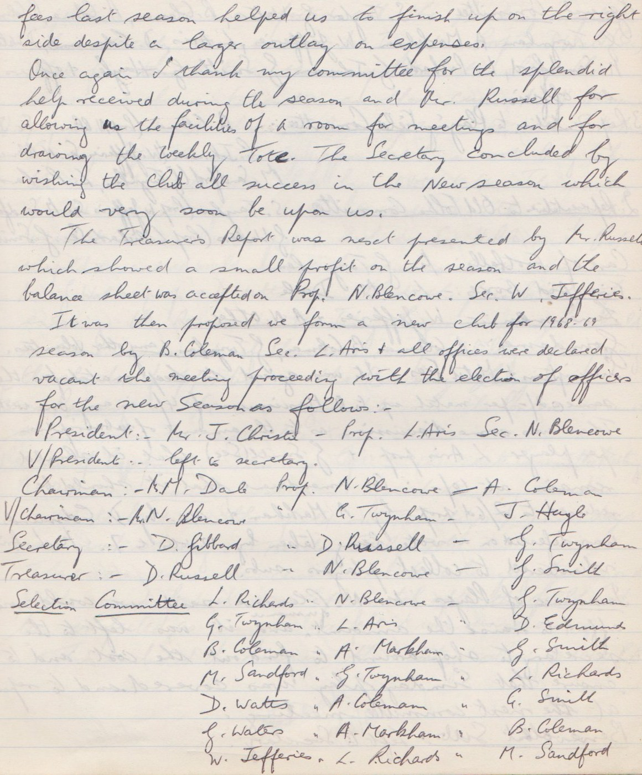

**Continued**

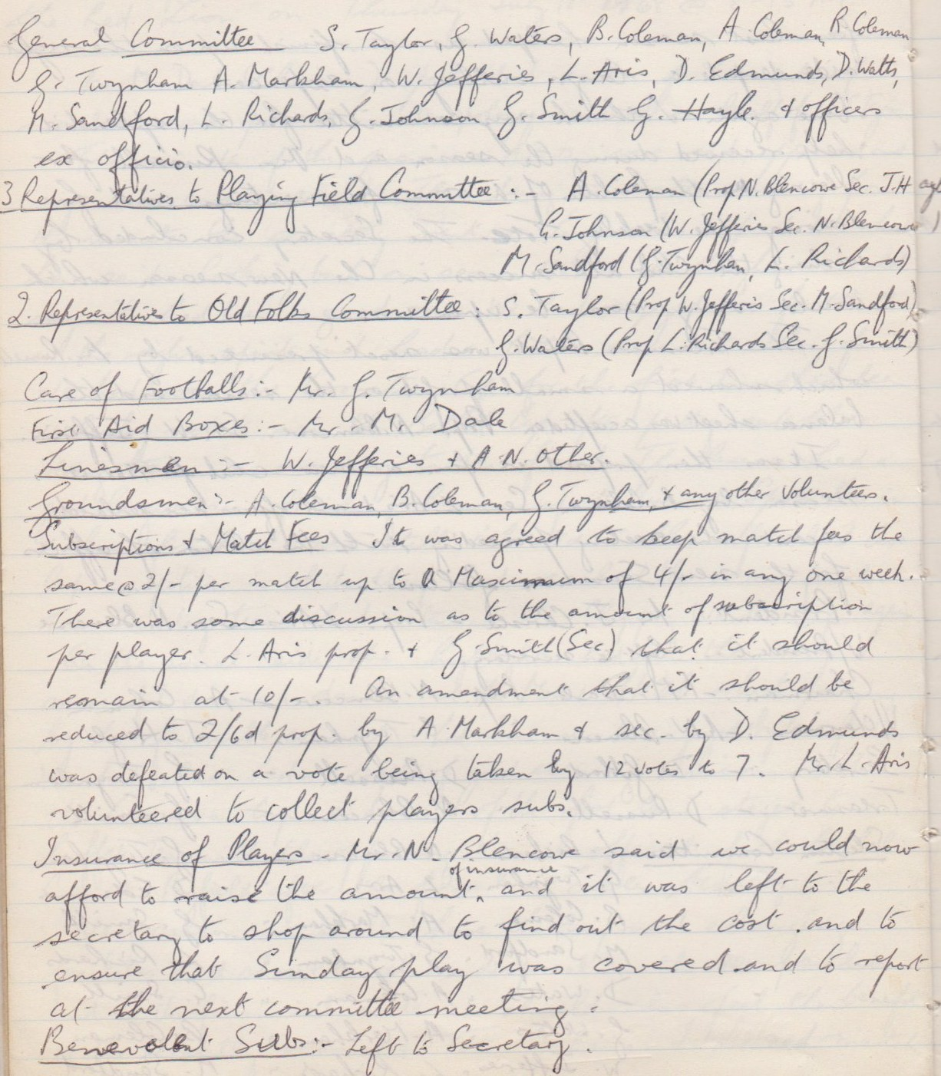

**Continued**

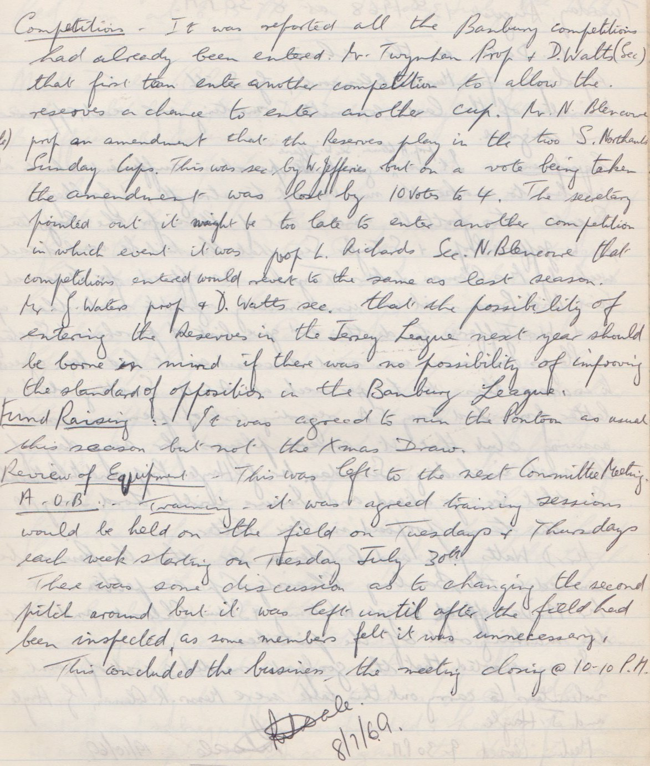

**General Committee Meeting**

**August 13th 1968**

